**The Contemporary Jewel as never seen before**

**Artistar Jewels 2018 makes its talents shine**

**Artistar Jewels: international showcase for the contemporary jewelry talents**

**Artistar Jewels,** reference organization for all the international artists and designer of the contemporary jewellery, selected the new protagonists of the unmissable event **Artistar Jewels 2018,** sponsored by **Comune di Milano**. The initiative, full of **news**, will take place during the **Milan Fashion Week from February 22nd to February 25th 2018**, at **Palazzo dei Giureconsulti**, nearby the Dome Cathedral in **Milan**.

**Artistar Jewels**’ main goal is to create **great chances** for the artists to **reach success**. The selected strategies have been improved every year and they lead every year the participants to have a direct connection with the international market. They guarantee high visibility thanks to the development of commercial and distributive networks and to the possibility of selling their creations to the public

**The main news** of this new edition is indeed the involvement of several **international concept stores** that will select brands that will be included in their shops: **16metriqudri** is a concept store in the hearth of Udine, meeting point of art and craftsmanship; **Creativity Oggetti** is a Turin gallery specialized in contemporary arts and Applied Arts since 2001; **Materie** is a design shop-gallery based in Rome. It shows a selection of contemporary jewels carefully researched. **Mio Store** is base in Firenze and it selects an elegant and contemporary design, that gives room to creativity in its more natural form; **Nuovum** is a Barcellona concept store where you can find jewels, decorative and art objects; **Ottobarradieci** of Bergamo is an original space dedicated to design. Reference for all those who are looking for unique and not mainstream products; **Oukan** is a concept store based in Berlin. Its pieces have an exclusive and individual style. **Tiberius** is a shop – concept store located in Vienna which has always distinguished itself for its irreverent, non conventional and provocative and it has now become the best showcase for design and lifestyle of the fashion world.

**After the event in February, Artistar Jewels will cross the Italian borders.**

**A touring exhibition of 30 pieces**, selected by the jury of te contest, will touch important **European locations**, as the gallery **ICKX Contemporary Jewelry** of **Brussels,** knows for the variety of the pieces with singular design, sober to minimalist, in which every piece is unique or realised in small series

**The 2018 contest involves many other awards.**

**Three winners will take part for free at the Artistar Jewels 2019** project and they will be dedicated special contest in the 2019 volume. **Their works** will also be included in the touring exhibition.

**A young designer** will have the chance **to attend, free of charge, the Professional Goldsmithing course offered by Scuola Orafa Ambrosiana of Milan**, where they will learn the main lab technique and will realize goldsmith products designed by the School.

**Two designers will be chosen to participate in two European fairs in 2018: Sieraad Art Fair and AUTOR International Contemporary Jewelry Fair.**

**The first one will take place in Amsterdam in November. Sieraad Art Fair** is the most important international fair of the Netherland, where the participants, artists and designers of contemporary jewellery coming for the 5 continents, will have the chance to directly selling their creations to the public.

The **AUTOR International Contemporary Jewelry Fair** will take place on the 5th and 6th of May in Bucharest. It’s the most important event of contemporary jewellery in the Eastern Europe. It shows great talents allowing the conversation between designers, consumers, collectors, galleries and distributors.

The jury made of field experts, that will have the “burden” of allocating this awards is composed by: **Elisabetta Barracchia** – Editor in Chief of Vogue Accessory and Creative Director of the Fashion Department of Vanity Fair, **Astrid Berens** - Director of SIERAAD ART FAIR, **Maristella Campi** – Fashion and custom journalists, **Gianni De Liguoro** – Founder and owner of maison De Liguoro, **Dan Piersinaru** - Director and founder of AUTOR, **Irina Slesareva** - Chief Editor of Jewellery Review Magazine and Creative Director of Russian Line Jewellery Contest , **Guido Solari** - Founder and Owner of Scuola Orafa Ambrosiana of Milano via Savona, 20

The disclosure of the awards and of the prestigious jury are only a preview of Artistar Jewels 2018. Many are the news that will be revealed in the next months-

Milan, October 24th 2017

**ARTISTAR JEWELS PROFILE**: Artistar Jewels is the landmark for all the artists and designers of contemporary jewellery. Through different strategies, it promotes them inserting them in an international market in constant evolution. Artistar offers several services useful to guide the artists in their professional growth; events creation in all the world, planning of customized communication strategies, creation of new business opportunities and placement in the market are only some of the services for the artists that entrust their growth to it. The main scope is the development of useful chances for our artists to get them to success

MEDIA PARTNER

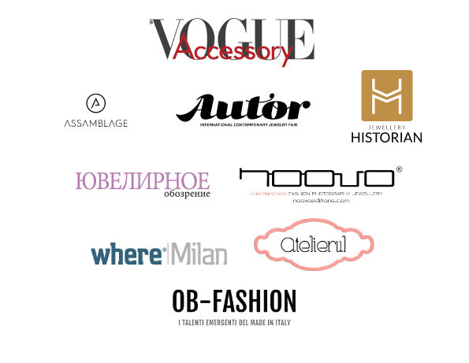

**ARTISTAR PRESS OFFICE**

Cristina Micheli

Tel: + 39 02 365 80 208

E-mail: [press@artistar.it](mailto:press@artistar.it)

**The press kit with the press releases, company profile, high res images is available at this link:** [**PRESS RELEASE**](http://www.artistar.it/cms.php?p=aj2018_pressrelease&lang=en)